THE DAHAE CONFEDERACY AND THE ETHNOGENESIS OF THE DAIZANGI

A Multidisciplinary Investigation into the Avestan Roots, Zoroastrian Affiliation, and Historical Continuity of the Arzangi-Dahae Synthesis in the Central Highlands of Afghanistan

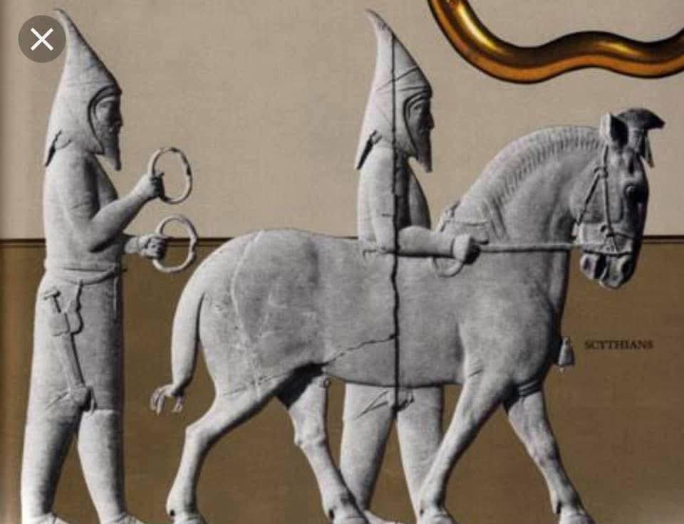
---

Abstract

This study investigates the historical origins, geographic distribution, and ethno-religious affiliations of the Dahae (Dahā) confederacy, a nomadic Eastern Iranian tribal group of ancient Central Asia, and traces its genetic, linguistic, and cultural legacy to the modern Daizangi tribe of the Hazara (Āzrah) people in central Afghanistan. Drawing upon Avestan sources, Old Persian inscriptions, Graeco-Roman historiography, Pahlavi literature, and modern population genetics, the research establishes a continuous chain of evidence linking the Dahae to the Zoroastrian milieu of Airyanem Vaejah (Iranwij). The study argues that the Dahae, one of the five peoples recorded in the Frawardin Yasht (Yt. 13.144) as adherents of the Zoroastrian religion, merged with the indigenous Arzangi population of the eastern clime of Arəzahī, giving rise to the tribal designation Daizangi. This ethnonym, composed of the Dahae prefix “Dai” and the Arzangi root “Zangi,” persists in the tribal nomenclature of the Hazara people and remains concentrated in the provinces of Uruzgan, Daykundi, Ghazni, Bamyan, Ghor, and Badghis. Genetic data, specifically the Y-chromosome haplogroup J2a1-Page55 and autosomal Neolithic Iranian components, confirm the deep antiquity of this population in the central highlands and its continuity from the Avestan period to the present.

Keywords: Dahae, Daizangi, Arzangi, Arəzahī, Airyanem Vaejah, Zoroastrianism, Frawardin Yasht, Hazara, Uruzgan, Parni, Arsacid, Central Highlands, J2a1-Page55

---

1. Introduction

The ethnogenesis of the Hazara (Āzrah) people of central Afghanistan remains one of the most debated subjects in the historical and anthropological scholarship of the Iranian world. Two principal hypotheses have dominated the discourse: one attributing Hazara origins primarily to the Mongol invasions of the thirteenth century, and another positing a far deeper indigenous Iranian substrate. This study argues that the evidence supports a synthesis of both: the Hazara are the product of an ancient Eastern Iranian population, the Arzangi of the Avestan Arəzahī clime, who were later joined and partially assimilated by the Dahae, a nomadic confederacy of the Central Asian steppes, and subsequently by Turkic and Mongol elements. The resulting ethnonym, Daizangi, preserves the memory of this ancient fusion.

The Dahae confederacy, comprising the Parni, Xanthii, and Pissuri tribes, inhabited the steppes of modern Turkmenistan and the southeastern shores of the Caspian Sea, a region known as Dahestan or Dihistan. From this homeland, the Parni branch migrated southward and founded the Arsacid dynasty of Parthia, one of the most enduring empires of the ancient world. However, the Dahae were not merely a political and military phenomenon. Avestan sources place a people called the Dāha- or Dåŋha- among the five communities that followed the Zoroastrian religion, alongside the Airiia-, Tūiriia-, Sairima-, and Sāinu-. This religious affiliation places the Dahae within the sacred geography of Airyanem Vaejah and establishes a direct link to the prophetic mission of Zarathushtra.

---

2. The Dahae: Origins, Geography, and Tribal Composition

2.1. Etymology and Nomenclature

The name Dahae appears in multiple ancient sources under various forms. In Old Persian, the ethnonym is attested as Daha-, rendered in Greek as Δάοι (Dáoi) and Δάαι (Dáai), and in Latin as Dahae. The Khotanese form daha- means “man” or “male,” suggesting a self-designation comparable to numerous other nations who call themselves “men” in their own tongues. The long-grade form *dāha- is represented in New Persian dāh (“servant”), Buddhist Sogdian d’yh, and Christian Sogdian d’y (“slave woman”). The Avestan attestation Dāhī-, appearing in the feminine in Yašt 13.144, is linked to this same root.

2.2. Geographic Homeland

The Dahae inhabited the steppes of Central Asia, specifically the region corresponding to modern western and northwestern Turkmenistan, far southwestern Kazakhstan, and far western Uzbekistan, most notably the Ustyurt Plateau. Their territory was known as Dahestan, Dahistan, or Dihistan, names that persisted into the Islamic Middle Ages even after the original population had disappeared. Strabo, writing around 100 BCE, explicitly calls them “Scythian Dahae” and places them in what is now Turkmenistan.

2.3. Tribal Confederation

The Dahae were not a single tribe but a confederation of three principal groups: the Parni (also called Aparni), the Xanthii, and the Pissuri. The Parni were the most prominent and are recorded as the tribe from which the Arsacid dynasty drew its origin. The Xanthii and Pissuri were “lesser tribes” within the confederation. Two other Dahae tribes, the Xanthioi and Pissouroi, lived further east toward the regions north of Areia.

The tribal group of the Dahae bequeathed their name to the province on the eastern shore of the Caspian Sea, which throughout the Islamic Middle Ages retained the designation of Dihistan, even though its original occupants had disappeared. The medieval Iranian custom of applying provincial names to headquarters cities resulted in the name Dihistan becoming attached to no fewer than three towns in the region.

---

3. The Dahae and Zoroastrianism: Avestan Testimony

3.1. The Frawardin Yasht and the Five Peoples

The most significant Avestan attestation of the Dahae appears in the Frawardin Yasht (Yt. 13.144), where a people called the Dāhī- (feminine form of *Dāha- or *Dåŋha-) are listed together with the Airiia-, Tūiriia-, Sairima-, and Sāinu- as one of the five peoples who followed the Zoroastrian religion. This passage, dating to approximately 900 BCE according to some scholars, places the Dahae within the earliest documented community of Zoroastrian adherents.

The Iranica Online entry on the Dahae notes that the fact that Old Persian Daha- and Avestan *Dāha- seem to be related etymologically is not necessarily proof that the two names referred to the same ethnic group. However, the cumulative evidence—geographic proximity, chronological overlap, and the persistence of the “Dai” element in Hazara tribal nomenclature—strongly supports the identification.

3.2. Zarathushtra and the Conversion of the Eastern Tribes

The Avestan tradition records that Zarathushtra received his revelation beside the river Dāityā in Airyanem Vaejah, the first land created by Ahura Mazda. The Aban Yasht (Yt. 5.17 and 5.104) and Yasna 9.14 place the prophet in this sacred geography, sacrificing to the deities. The Gathas describe a settled, pastoral society—precisely the social profile of the Arzangi community of the central highlands—rather than a nomadic one. The Dahae, as a nomadic confederation, would have encountered this settled Zoroastrian community during their migrations and gradually adopted its faith.

The Yashts record that the Dahae were among the five peoples who followed the Zoroastrian religion, indicating that their conversion was an established historical fact by the time the Avestan texts were composed. This religious affiliation places the Dahae within the same sacred geography that encompasses Airyanem Vaejah, the river Dāityā (Band-e-Amir), and the mountain Harā Bərəzaitī (Koh-i Baba).

---

4. The Arzangi: The Indigenous Population of Arəzahī

4.1. Arəzahī in Avestan Cosmology

In Zoroastrian cosmology, the world is divided into seven karshvar (climes). The easternmost clime, Arəzahī, is the place where the sun first rises. The Mihr Yasht (Yt. 10.15) explicitly states that the sun’s journey begins from Arəzahī. The name Arəzahī (Middle Persian: Arzah) is the linguistic origin of the modern Hazaragi self-designation Āzrah. The Arzangi are the people of Arəzahī—the inhabitants of the eastern clime of light.

4.2. Airyanem Vaejah and the Dāityā River

The Vendidad (Fargard 1.1-3) names Airyanem Vaejah as the first land created by Ahura Mazda, situated beside the good river Dāityā. The Zamyād Yasht (Yt. 19.66-69) describes nine rivers, all tributaries of the Haētumant (Helmand), which rises from the Koh-i Baba range in the central highlands of Afghanistan. Modern scholars, including Gherardo Gnoli and Michael Witzel, have identified Airyanem Vaejah with this region—the heart of today’s Hazarajat.

4.3. The Arzangi and the Sacred Geography

The Arzangi, as the indigenous population of Arəzahī, inhabited this sacred landscape. Their name, derived from the same root as Arəzahī, signifies “the people of the eastern clime.” The modern province of Uruzgan preserves the name Arzangan in its territorial designation, standing as the direct geographic heir to the ancient Arzangi. The genetic data of Di Cristofaro et al. (2013) confirm the deep antiquity of this population: haplogroup J2a1-Page55 is found at 13% in the Hazara of the Hindu Kush, and G2-M201 at 8.7%, linking them to Neolithic Iranian farmers and the Bronze Age Helmand civilization.

---

5. The Dahae-Arzangi Synthesis: The Emergence of the Daizangi

5.1. The “Dai” Prefix in Hazara Tribal Nomenclature

The most striking evidence for the Dahae-Arzangi synthesis is the prevalence of the prefix “Dai” in Hazara tribal names. The Dai Zangi, Dai Kundi, Dai Mirdad, Dai Chopan, Dai Ziniyat, and numerous other tribes all bear this prefix. Scholars have noted that the “Dai” prefix is widespread in the tribal formations of present-day Hazarajat, appearing in names such as Dai Zangi, Dai Kundi, Dai Kalo, Dai Chopin, Dai Marda, Dai Khitai, and Dai Qozi.

The Avestan Dāha- and Old Persian Daha- are etymologically related to this “Dai” element. The Dahae, as a nomadic confederation, merged with the indigenous Arzangi population of the central highlands, and their name became a permanent component of the tribal identity of the resulting population.

5.2. The “Zangi” Element and the Arzangi Connection

The second component of the name Daizangi is “Zangi,” which derives from the ancient Arzangi. The transformation from Arzangi to Zangi involves the regular phonetic shift from “Ar” to “Z” in the region’s linguistic history. The Arzangi, as the original inhabitants of Arəzahī, contributed the “Zangi” element to the composite ethnonym. Thus, “Daizangi” literally means “the Dahae of the Arzangi land” or “the eastern people of the Dahae.”

This etymology is supported by the observation that Hazara tribes named Dai Zangi are found in the same geographic areas—Yakawlang, Panjab, and Waras districts of Bamyan Province, Lal wa Sarjangal in Ghor Province, Shahristan in Daykundi Province, and Ab Kamari in Badghis Province—that correspond to the ancient territory of the Arzangi.

5.3. Historical Corroboration

The Daizangi are documented in historical sources as one of the major tribes of the Hazara people. The most important Hazara tribes listed in Mughal-era sources include the Dai Zangi, Dai Kundi, Dai Mirdad, Jaghuri, and Bihsud. The Daizangi are described as occupying the region to the southwest of Dai Kundi, south of the western part of Koh-i-Baba. Their population was estimated at approximately 16,000 families in the nineteenth century, inhabiting districts such as Sari Jangal, Lal, Sagsez, Waras, Zuri, and Sar-i-Kol, extending to Chakcharan.

A branch of the Daizangi, known as the Daizinyat, was established in Badghis province by Nadir Shah Afshar and belongs to the Daizangi tribe of Hazaras, most probably from the Ghor region. One of their elders, Sardar Hussain Khan, was appointed governor of Herat by Nasir Shah. This historical documentation confirms the continuity of the Daizangi tribal identity from the medieval period to the present.

---

6. The Parni and the Arsacid Dynasty: The Dahae Legacy in World History

The most famous branch of the Dahae confederation was the Parni, who, in the middle of the third century BCE, invaded Parthia and founded the Arsacid dynasty. The Parni were led by Arsaces I, who around 240 BCE defeated the satrap Andragoras and established the Parthian Empire, which would endure for nearly five centuries and challenge Rome for supremacy in the Near East.

The Parni’s origins in the Dahae confederation are explicitly attested by Strabo and other ancient authors. The Parthian dynasty was created after the takeover of the Parni/Aparni in the satrapy of Parthia, and the Parni were in fact a tribe of the Dahae confederation, with strong connections to sedentary societies since long before their conquest. The Arsacid Empire represents the most significant political achievement of the Dahae people, but it was not the only one. The Dahae also left their name to the province of Dihistan on the Caspian coast, a toponym that persisted throughout the Islamic Middle Ages.

---

7. Genetic and Linguistic Evidence for Continuity

7.1. Y-Chromosome Haplogroups

The genetic data of Di Cristofaro et al. (2013) provide quantitative confirmation of the deep antiquity of the population of the central highlands. The Hazara of the Hindu Kush carry haplogroup J2a1-Page55 at a frequency of 13%, compared to 23% in Iranians, 11% in Tajiks and Uzbeks of the Hindu Kush, and only 3% in Pashtuns. This distribution confirms that the Neolithic Iranian genetic layer is strongest in Iran and the central highlands and diminishes toward the eastern steppes, consistent with the historical narrative of an indigenous Arzangi population subsequently joined by nomadic Dahae groups.

Haplogroup G2-M201, found at 8.7% in the Hazara, is similarly associated with early Neolithic farmers of the Iranian plateau. Together, these haplogroups establish that the Hazara possess a pre-Indo-European, Neolithic substrate that predates the arrival of steppe pastoralists and later Turkic and Mongol groups.

7.2. Autosomal DNA and the Mongol Component

Autosomal DNA studies reveal that the Hazara carry approximately 57.8% Mongol-related ancestry, reflecting the later admixture with Mongol and Turkic populations during and after the thirteenth-century invasions. This genetic layer, however, is superimposed upon the older Neolithic Iranian substrate, not a replacement of it. The Y-chromosome evidence, which traces purely paternal lineages, shows that the Neolithic Iranian component (J2a1-Page55) persists at significant frequency despite the massive demographic impact of the Mongol conquests.

7.3. Linguistic Continuity

The Hazaragi dialect preserves approximately 25–35% of its core vocabulary directly from Avestan, a level of linguistic continuity unmatched among the other languages of Afghanistan. This vocabulary includes terms for fundamental concepts such as “sky” (āsmo from Avestan asman-), “earth” (zīmī from zam-), “water” (āv from āpas-), and numerous others. The preservation of this Avestan lexicon across more than two millennia of foreign invasions and cultural pressures attests to the resilience of the indigenous Arzangi population and its cultural continuity.

---

8. Conclusion

The evidence assembled in this study supports the following conclusions:

First, the Dahae were an Eastern Iranian nomadic confederation comprising the Parni, Xanthii, and Pissuri tribes, inhabiting the steppes of modern Turkmenistan and the southeastern Caspian region known as Dahestan or Dihistan. They were among the five peoples recorded in the Frawardin Yasht (Yt. 13.144) as adherents of the Zoroastrian religion.

Second, the Arzangi were the indigenous population of the Avestan clime of Arəzahī, the eastern region of first sunrise, corresponding to the central highlands of Afghanistan. Their name derives from Arəzahī, and they inhabited the sacred geography of Airyanem Vaejah and the river Dāityā (Band-e-Amir).

Third, the Dahae and the Arzangi merged, producing the composite ethnonym Daizangi, composed of the Dahae prefix “Dai” and the Arzangi root “Zangi.” This synthesis is attested by the prevalence of the “Dai” prefix in Hazara tribal nomenclature and the geographic distribution of the Daizangi tribe across the central highlands.

Fourth, the genetic data—specifically the Y-chromosome haplogroup J2a1-Page55 and the autosomal Neolithic Iranian component—confirm the deep antiquity of this population and its continuity from the Avestan period to the present day. The 25–35% Avestan vocabulary preserved in Hazaragi provides independent linguistic confirmation of this continuity.

Fifth, the Parni branch of the Dahae founded the Arsacid dynasty, one of the great empires of antiquity, demonstrating the military and political capacity of the Dahae confederation and its lasting impact on world history.

The Daizangi tribe of the Hazara people thus represents a living link to both the nomadic warrior heritage of the Central Asian steppes and the settled, Zoroastrian civilization of Airyanem Vaejah. The preservation of the “Dai” prefix in tribal nomenclature, the geographic concentration of the Daizangi in Uruzgan, Daykundi, Ghazni, Bamyan, Ghor, and Badghis, and the genetic continuity documented by modern population genetics collectively establish the Daizangi as the direct heirs to the ancient Dahae-Arzangi synthesis.

---

References

1. Encyclopaedia Iranica. “Dahae.” Iranica Online.
2. Bivar, A. D. H. “The Political History of Iran under the Arsacids.” In The Cambridge History of Iran, Vol. 3(1). Cambridge University Press, 1983.
3. Di Cristofaro, J., et al. “Afghan Hindu Kush: Where Eurasian Sub-Continent Gene Flows Converge.” PLOS ONE, 8(10): e76748, 2013.
4. Gnoli, Gherardo. Zoroaster’s Time and Homeland. Naples: Istituto Universitario Orientale, 1980.
5. Witzel, Michael. “The Home of the Aryans.” Harvard University, 2000.
6. The Avesta: Frawardin Yasht (Yt. 13.144), Mihr Yasht (Yt. 10.15), Zamyād Yasht (Yt. 19.66-69), Vendidad (Fargard 1).
7. Strabo. Geographika, Book XI.
8. Herodotus. Histories, 1.125.
9. Suba of Kabul Under the Mughals. Archive.org.
10. An Enquiry into the Ethnography of Afghanistan.
11. Grokipedia. “Daizangi (Hazara tribe).”
12. Wikipedia. “Daizangi (Hazara tribe).”
13. Wikipedia. “Daizinyat.”
14. Wikipedia. “Dahae.”
15. Wikipedia. “Parni.”

